
GRACE BOWMAN
ISSA Certified Personal Trainer with continuing education Certifications in Nutrition & Strength and Conditioning
WHY I BECAME A TRAINER
Working towards a healthier lifestyle has given me a completely different outlook on life and my overall health. My health journey all started with a passion for taking care of livestock on a Dairy Farm. I had not only lost weight but started to feel stronger and more confident in my abilities. Finding enjoyment in movement, I incorporated Nutritional changes with online at home workouts then decided to up my game with strength and started going to a gym. Suddenly, it became my mission to help others find a Healthier outlook towards Fitness and Nutrition so they could experience the shift in mindset I did. It’s about being able to maintain healthier habits to keep your body and mind healthy throughout the difficulties of life. I also just LOVE to lift weights and feeling strong! Fitness gave me the confidence to do many things including crazy hiking experiences and a solo trip to South Korea. I am not only great for beginners but also those wanting to gain strength!

@grace_fitnutrish


(336)-401-7042
GBFitnutrish@gmail.com

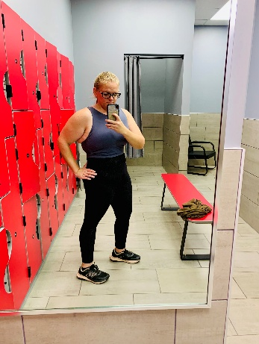


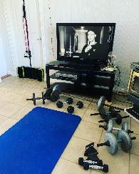

FREE CONSULTATIONS:
Determining if Personal Training is for you and what specific goals you have towards fitness and nutrition. Determining Package, workout sessions and pricing that's best for you. Or just needing some tips to get started in the gym.
STRENGTH & CONDITIONING:

Know the basics but want to start increasing weight safely and determine which method is best for you. Nutritional needs to help fuel your body while increasing intensity. Emotional Stress Management Tips.
NUTRITION ONLY:

Learning ways to build a better Nutritional foundation to implement different health goals. Meal ideas that are quick, simple and delicious, cooking methods, and ways to eat out and still maintain nutritional foundations. Emotional Stress Management Tips.
BEGINNER PACKAGE:
Form techniques, understanding equipment, understanding how to set up workouts and ways to modify exercises if needed. Nutritional advice to ease into changing your mindset around fueling your body. Emotional Stress Management Tips

**** For those with a strict budget please reach out and let’s discuss options before thinking you can’t!! All include free 1 hour consultation and nutritional guidance/advice/meal ideas. ****
Beginner Prices
- 1 Hour per week with 2 one-hour sessions created for independent workouts or 3, 30-minute workouts to do independently. $50 or $190 Per month.
- 3 Sessions per week that are 30 minutes - $70 per week or $280 per month.
- 2-hour long sessions per week plus programing for workouts to do independently at home or the gym. - $90 or $340 per month.
Strength & Conditioning Prices
- 1 Hour per week with 2 one-hour sessions created for independent workouts or 3, 30-minute workouts to do independently. $50 Per Week or $190 Per month.
- 3 Sessions per week that are 30 minutes - $70 per week or $280 per month.
- 2-hour long sessions per week plus programing for workouts to do independently at home or the gym. - $90 or $340 per month.
Nutrition Prices
- Meetings/Calls. Meal ideas/planning. 1 hour long, once a week. $30

